ZD方管
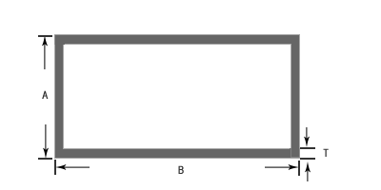
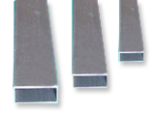
代号 | A(mm) | B(mm) | T(mm) | 重量(kg/m)
F401 | 25.4 | 25.4 | 1.2 | 0.315
F402 | 25.4 | 38.1 | 1.2 | 0.397
F403 | 25.4 | 50.8 | 1.2 | 0.48
F404 | 25.4 | 70 | 1.2 | 0.605
F005 | 25.4 | 76.2 | 1.2 | 0.645
F006 | 25.4 | 80 | 1.2 | 0.670
F006H | 25.4 | 80 | 1.4 | 0.776
F007 | 25.4 | 90 | 1.2 | 0.735
F008 | 25.4 | 101.6 | 1.2 | 0.810
F009 | 44.4 | 76.2 | 1.2 | 0.769
F010 | 44.4 | 85.4 | 1.2 | 0.829
F011 | 44.4 | 101.6 | 1.2 | 0.934
F012 | 38.1 | 38.1 | 1.2 | 0.480
F013 | 50.8 | 50.8 | 1.2 | 0.645
F016 | 44.4 | 80 | 1.2 | 0.793
F018 | 25 | 85 | 1.2 | 0.7
F020 | 44.4 | 101.6 | 2 | 1.53
F021 | 40 | 100 | 4.5 | 3.2
F022 | 25 | 100 | 2 | 1.307
F023 | 44.45 | 76.2 | 2 | 1.253
F025 | 45 | 75 | 1.5 | 0.952
F026 | 44.5 | 97 | 2.5 | 1.85
F032 | 10 | 20 | 1.0 | 0.198
F034 | 50 | 50 | 1.5 | 0.789
F036 | 40 | 50 | 1.5 | 0.708
F037 | 18 | 40 | 1.5 | 0.447
F038 | 18 | 50 | 1.5 | 0.529

江苏宏博机械制造有限公司

总部地址:江苏海安南莫工业园区
董事长：韩青云 13906278039
生产科：赵 巍 13962782598

总部电话:0513-88475696 88473588
总部传真：0513-88473988

分部电话:0513-88482413 88482449
分部传真：0513-88485068

公司网址:http://www.hongbojs.com/
E-mail:zdly@zdly.com hb@hongbojs.com

